Grade 7 Accelerated · Unit 5 · Lessons 8–9  Converting Mass, Area and Volume  Question Bank - Additional 5.08 | Name______________________  Date______________________  Period____________________

Show your work. Circle your final answer.
For questions 1 through 4, convert with the ratio given.
1. . 40 lb to kilograms.

2. 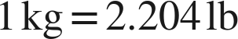. 5 kg to pounds.

3. . 12 gal to liters.

4. . 50 L to gallons.

For questions 5 through 7, say how many times the ratio is used.
5. 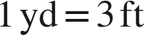. 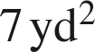 to square feet.

6.  and . 40 fl oz to liters.

7. . 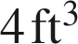 to cubic inches.

Choose one.
8. . A floor is 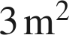 in area. How many square centimeters is that?
○ A. 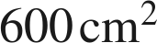
○ B. 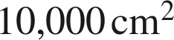
○ C. 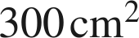
○ D. 